GAD101 Readings & Assignments: Week 3

Week 3 Reading
By Monday, April 14, 2008 please read the following:
- Week 3 Lecture
- From the textbook, Novak, Jeannie. Game Development Essentials an Introduction. 2nd ed. Clifton Park: Thomson/Delmar Learning, 2007, read:
  - Chapter 4: Storytelling: Creating the Narrative
  - Chapter 5: Characters: Creating the Identity
Week 3 Assignments Overview
Assignment Summary: Week 3 | Due Date
Assignment 1: Discussion Questions | Tuesday, April 15, 2008
Assignment 2: Premise | Tuesday, April 15, 2008
Assignment 3: Backstory | Thursday, April 17, 2008
Assignment 4: Character Descriptions | Saturday, April 19, 2008

Welcome to Week 3
Welcome to Week 3 of GAD101! Last week, we focused on the game developer perspective and discussed game applications and goals, platforms, and genres. You applied your knowledge of platform-specific and genre-specific game development to original game ideas—and you provided a detailed case study analysis of a pre-existing game.
Now that you have a clear background of what makes a game great, we will dig a little deeper starting this week and focus on more specific topics in game development. This week, we will go into more detail on story and character development—looking at the roles of game designer and writer. Assignments include creating a premise, backstory, synopsis and several character descriptions for an original game idea. By the end of this week, you will have a strong grasp of how to utilize dramatic elements to make a game compelling and interesting to the player.
Learning Outcomes:
- Distinguish between traditional linear storytelling and nonlinear storytelling.
- Create a premise and backstory for an original game.
- Identify archetypes associated with game characters.
- Create descriptions of original game characters.

Traditional Story Structure
Before you apply game-specific story devices to a narrative, it’s important to understand traditional story structure. You learned about the Hollywood Three-Act structure and Joseph Campbell’s “The Hero’s Journey” structure. In preparation for your assignments this week, make sure you can identify these traditional structures in other media (such as film).
Try to watch three films this week and analyze their structure. First, determine where the transitions are between Acts I, II, and III. (Traditional scriptwriting is such a precise science that each act is “timed.” If you want to test this, note the time when each act begins or ends.)

Next, see if you can identify story elements related to “The Hero’s Journey” scenario. You’ll notice that many films from Star Wars to The Matrix follow this pattern in great detail. Start with the main character—who is usually the “hero” of the story. What situations does the hero face in the story? How does the hero solve problems? How does the hero grow and change throughout the story?
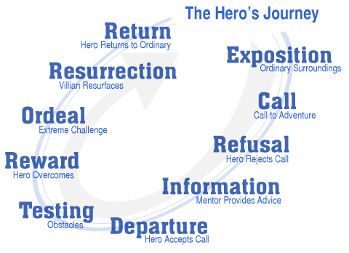
To help you more easily identify the path the hero takes through the “Hero’s Journey,” combine both the Three-Act and “Hero’s Journey” structures. Where does Act I of the “Hero’s Journey” scenario end? Where does Act II end?
Let’s apply these traditional story structure elements to games. You’ll notice that some games such as Half-Life and Final Fantasy exhibit traditional story elements. However, games go beyond the traditional storytelling embraced by most films and add several dimensions to a narrative. Let’s look more closely at the difference between games and films.

Game Narrative
Ever since it was announced in 2003 that game revenues were beginning to exceed box office figures, the film industry began to take the game industry seriously. Now, game adaptations of films are commonplace—and it’s not unheard of for members of the film industry to “migrate” over to the game industry. Some game companies have recently focused on “courting” the film industry—as illustrated in Electronic Arts’ glamorous “Hollywood-like” game studio that was launched in 2004. What of all this mingling between two entertainment industries? On the surface, games and films seem well-suited for one another. Besides, aren’t games really just interactive movies?
This statement couldn’t be further from the truth! There are several major differences between games and films:
- Films are linear; games are non-linear
- Films are watched passively by an audience; games are “controlled” by players
- Films always end; some games don’t ever end
- Films will keep the same narrative no matter how many times they’re watched; games may change dramatically each time they’re played
- Films contain characters that the audience may identify with; games contain characters that players may “inhabit”
These are just a few differences. Can you think of others? How do these differences affect the way stories are told in games as opposed to films? Members of the film industry need to understand these differences before effectively contributing to the game industry—and so do you!
After watching your movies this week, you probably noticed that all of them illustrated only one linear path through a story. Even when films attempt to be nonlinear—as in Run Lola Run and Time Code—they are still limited by the media of film or video (which are both linear)! In a game, however, developers have the opportunity to create non-linear narratives—allowing for many story variations.
Another major difference between the film and game industries is process by which stories are developed for both media. A writer or team of writers creates a “script” for a film or television program. Only on rare occasions in the game industry do writers get hired to write a game script. Instead, designers often focus on story and character development. (You will learn more about the designer role in the coming weeks.) Other than scripts written for cinematics or cut-scenes, game “scripts” are very different from screenplays or teleplays.
Why do you think “cut-scene” scripts are similar to film or television scripts? Cut-scenes have a linear narrative—just like a film. Keep in mind that players do not have any control over a cut-scene. In fact, players become “audience members” during a cut-scene—watching rather than playing. Do not overuse cut-scenes in games, or the players will wish they were just watching a movie instead on the big screen!
A game script must illustrate all the story paths that are taken through a game. Some of those paths depend on what actions the players take. If a player decides to do “A,” one path might be taken; if a player decides to do “B,” another path might be taken—and so on. The actions that players take could be anything from particular dialogue responses to physical actions (such as engaging in combat or eating). See the story and dialogue examples from Earth & Beyond in your textbook to see how these paths are reflected in a game script.
The paths in a game script reflect a game’s interactivity because the paths are chosen by the players. As you will see next week, interactivity and narrative should intersect seamlessly in a game. However, there have been several debates in recent years about whether story or interactivity is more important. Some feel that a game’s theme and narrative are most important—and it’s the dramatic tension that motivates players to stay engrossed in the events taking place during the game. Others feel that the strategies players use to overcome challenges in the game are most important—and it is this “player control” that truly immerses players in the game, making players feel they’re a part of the game world!

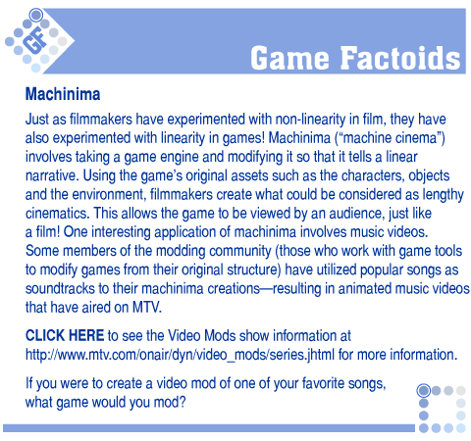
http://www.mtv.com/onair/dyn/video_mods/series.jhtml
If you play a “tabletop” game (such as a board, card or dice game), you will notice that less attention is paid to story and more emphasis is placed on the “mechanics” of the game (or how it is played). Play one of your favorite tabletop games and ask yourself these questions:
- Am I getting immersed in the game’s storyline?
- Am I getting caught up in the rules of the game, and actions I must take in order to win?
You will most likely feel more positively about the second question. Why is this? Now play a video or computer game. Do you feel equally about both of the above questions? If so, this means that the game has maintained an excellent balance between story and interactivity. Next week, we will delve deeper into this topic during our discussion of gameplay.

Classic Character Archetypes
Some classic character archetypes are based on the work of psychologist Carl Jung (whose work also forms the basis of research in the area of psychotypes, as discussed in Week 1). Like traditional storytelling structure, these archetypes exist in all forms of narrative entertainment. As you are watching films to determine their narrative structure, you should also consider character archetypes such as the following:
- Hero: You’ll find that the hero of the story is usually the protagonist—otherwise known as the main character. The hero archetype is really a manifestation of the “self”—which is why we tend to identify with this character.
- Shadow: There will almost always be a character that represents the hero’s “opposite.” This shadow character is usually the antagonist. This doesn’t mean that the shadow is the “enemy.” Instead, the shadow character could be an exotic presence that fascinates the hero—or simply “the other,” which the hero does not fully understand. The shadow character represents our dark side, which we project onto others.
- Anima/Animus: Jung discussed the anima and animus as representing a missing half of one’s personality. Men must come to terms with their anima (feminine soul), while women must come to terms with their animus (masculine soul). Once the anima/animus is encountered and embraced, the hero’s soul is complete. (Tom Cruise in Jerry Maguire said it bluntly when he told Rene Zellweger, “You complete me.”)
Additional archetypes discussed in your textbook—such as the trickster or shapeshifter—can be considered aspects of the shadow archetype. The trickster isn’t merely a jokester, but a character that isn’t what he or she initially appears to be (often fooling the hero of the story); the shapeshifter is often the manifestation of the hero’s shadow within the hero character’s persona (a la Dr. Jekyll’s Mr. Hyde and even Clark Kent’s Superman). These are just a few of Jung’s archetypes. See http://en.wikipedia.org/wiki/Archetype for further discussion—and see if you can find all of them in the films you review.

Game Characters
Most game characters can be classified into one of five basic types:
- animal
- fantasy
- mythic
- historical
- licensed
Think of your favorite game characters and consider whether most of them fit into a particular character type. Are any of these types associated with particular genres? For example, we know from our discussion of role-playing games (RPGs) last week that fantasy characters (and settings) are often associated with the RPG genre. Do the types above seem all-inclusive, or do you think there’s a category that has not been developed yet? When you go through your list of favorite game characters, you may find that some do not fit into any of these categories. If this is the case, create some new categories!
In a game, the protagonist (or “self”) is represented by a character known as an avatar—which is specifically controlled by the player. The word “avatar” comes from ancient Sanskrit and is defined as “the incarnation of a Hindu deity in human or animal form.” An example of this incarnation would be Buddha, which is considered an avatar of the god Vishnu. In this sense, an avatar in a game is an extension of the self and a representation of the player. No wonder some players identify so strongly with their avatars!
During this class, you should be playing at least one new game per week. Notice how you identify with your avatar while playing each game. Do you find that some games allow you to more closely identify with your avatar than other games do? Does this bond with your avatar make a game more enjoyable for you?
Now play a game that allows you to customize your own character. Does this customization process allow you to have a closer bond with your avatar? Do you have a feeling of “ownership”—as if you developed the character yourself? Let’s take this idea one step further and imagine that you had the ability to create a character whose physical and personality characteristics were virtually identical to your own. How would this affect your ability to play the game? Is it more enjoyable to take on the role of a character who might not be anything like yourself—who might do things that you may never do in the real world—or is it more satisfying to be yourself in a virtual world?

Game Story Documentation
You will be writing an original game premise, backstory, synopsis and character descriptions for this week's assignments. Although your premise is due first, you will need to put together a rough synopsis beforehand from which you'll be able to construct an appropriate premise. Begin by putting together a paragraph that outlines what happens in the game itself. Introduce the characters, setting and theme of the story. How does the action begin, and what are the player characters' goals in the story? We'll go into more detail on the synopsis soon, but let's discuss the format of the premise first.
Premise
Your premise should summarize the game's goal and get prospective players interested in purchasing the game. Think of the premise as a marketing summary. It's important that you write the premise so that it addresses the player directly. It should be in 2nd-person voice (“Take on the role of ...”) and should be no more than three sentences long. Test your premise on others before submitting it. Find out if people are intrigued by the premise. Do they want to find out more about the game after reading it? Also, see if people understand the story from the premise you've provided.
Backstory
Your backstory should simply answer the question: What happened before the game began? None of the information in the backstory should involve any in-game action. It should only give a background that ends when the game story actually begins. The backstory should take up no more than a paragraph or 3-5 sentences.
Synopsis
A game synopsis summarizes what happens after the game begins. But it's not written like a movie synopsis. Instead, it illustrates the general paths that can be taken through the game's story. When you write your own synopsis this week, you should refrain from focusing on every detail. Instead, spend just a few paragraphs discussing the general storyline and then listing the various paths that take place through it. One of the most straightforward ways to initially map your synopsis is to envision a story tree.
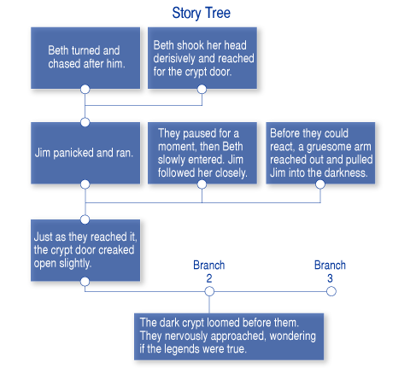

Characters
You will be putting together some character descriptions for one of your assignments this week. In order to prepare for this assignment, you should make sure you understand visual and verbal character development—as well as character triangles, arcs and movement. As you develop your game’s storyline, you will begin to create characters that will fit within it. One of the best ways to ensure that characters are tied to a game’s story is to create character triangles involving three characters. Each of the three characters in a triangle should be part of triangles with other characters.

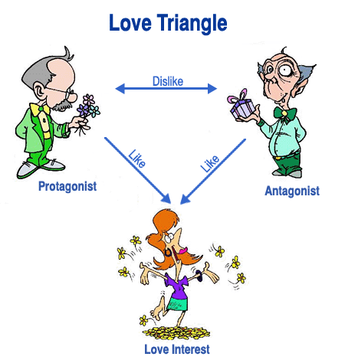
Keep in mind that a love triangle is just one type of character triangle! Other triangles could involve business, crime, family, or school. Each of the three characters you develop for this week’s assignment should be involved in at least two separate character triangles. This means that some triangles will involve characters other than those you will be describing. By creating these triangles, you will ensure that each of your characters will have a solid role in your story through relationships with other characters.
Many characters should also go through some sort of transformation in your game, instead of remaining stagnant. This transformation process is known as a character arc. For example, characters might gain experience, skills or knowledge—a character arc popular in RPGs. Other character arcs can be more internal—such as an emotional, cerebral or spiritual transformation. Abraham Maslow’s Hierarchy of Needs illustrates a model for human social development.
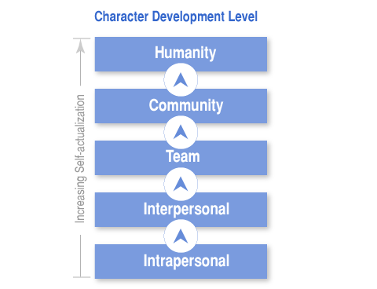
One interesting way to develop a character arc is by taking a character from one of Maslow’s levels to the next through the game. For example, a character can begin by being selfish (intrapersonal) and ends by learning to love another person (interpersonal). This sounds like a premise for many popular films, doesn’t it?! Have you noticed a similar pattern of character social development in games?
Your descriptions should reflect both the physical appearance and personality of your characters. Pay attention to such details as body type, skin tone, color scheme, ethnicity, gestures, nervous ticks, and facial expressions. Also, make sure you incorporate vocal tone, volume, and pace. What are the characters strengths and weaknesses, likes and dislikes, ambitions and fears? If you don’t know your characters intimately, they will seem superficial to players.
Next week, you will be creating a concept document, along with character and environmental art for your original game idea. Start making out preliminary concept sketches this week.
Summary
You have successfully completed the third week of GAD101! Now, you have begun to immerse yourself in developing original game content by focusing on story and character development. Next week, you will continue this creative process by learning about gameplay and how it actually intersects with story. At the end of next week, you will have also created a concept document and art for your original game idea!
* Some of the material contained in the GAD101 lecture material is adapted from Novak, J. (2005). Game development essentials: An introduction. Albany, NY: Thomson/Delmar. Used with permission.
Assignment 1: Discussion Questions
By Tuesday, respond to two discussion questions—one from the Storytelling topic, and one from the Character Development topic. Submit your responses to the appropriate topic in this Discussion Area.
By Thursday, April 17, 2008 post comments on your classmates' responses and submit to this Discussion Area. You can ask technical questions or respond generally to the overall experience. Always use constructive language, even in criticism, to work toward the goal of positive progress. Take advantage of this forum because you can learn from each other.
Assignment 1 Grading Criteria: | Maximum Points
Responses are logical, structured, and well-researched. | 4
Responses are clear and concise. | 4
Responses go beyond just answering the question and include personal thoughts, anecdotes and/or opinions. | 8
Total: | 16
For assistance with any problems you may have when completing this assignment—OR—to offer your assistance to classmates, please use the Problems and Solutions Discussion area located through the left side navigation link.
StoryTelling

• Members of the film industry are beginning to migrate to the game industry, in part due to revenue reports depicting the game industry as fast-growing, Several game studios are also attempting to recruit members of the “Hollywood” community. Discuss the differences between these two forms of entertainment (film and games), and provide three examples of how the intersection of these two forms of entertainment could change game content, structure, and delivery.
• There has been great debate in the game industry on which is more important—story or interactivity. Do you feel one is more important than the other? If so, which one—and why? What might you do to balance story and interactivity in a game?
• Why are game developers utilizing classic story structures such as Hollywood’s three-act structure and Campbell’s “hero’s journey” scenario? These classic structures provide a good base for game story development, but their somewhat predictable formulas don’t necessarily lend themselves to innovative game content. What elements of these story structures do you think work best? How would you choose to tell a story through a game environment?
• What are some dramatic storytelling devices used in games? Choose one of these devices and discuss how you would make it work within your original game storyline.
• How is machinima an example of industry convergence? What are the two industries involved, and how do they intersect? How does this new way of creating games affect game storytelling? Can you think of another way to intersect two industries so that storytelling is affected?
• Choose a “tabletop” (especially card or board) game with a distinct setting or premise. (If you want to see some cleverly-designed “tabletop” games, go to Funagain Games at www.funagain.com.) After familiarizing yourself with the game, discuss how you would adapt the game to electronic form. What story elements would you expand upon in order to create a more enriching, immersive experience for the player?

Storytelling has become increasingly important in games. These games, it is common for a game to have an epic story to go along with the game play. When answering these questions, think about the storylines that games used to have (for example, what was the story behind Pong?), and how the storylines have evolved in today's games.

Character Development
• In what ways can players identify with avatars during a game? What is the significance of being able to customize a player character?
• In what ways do characters “develop” in games? Discuss all aspects of character development and tie them in with story structure.
• Choose a character archetype and discuss its significance. Why are archetypes such as these used in games, film, and other media?
• Name three of your favorite game characters. Why do you like these characters? What are their character types and archetypes?
• If you were to create a customized character based on yourself, what would it be like? Describe yourself in terms of a game character. What are your physical and personality characteristics, goals, strengths and weaknesses, likes and dislikes, general mood? Discuss other characters that might also appear in the game. (Note: These characters may not necessarily be helpful, but could represent obstacles that prevent you from reaching your goals.)

Think about how characters are used in games today. Some games have very defined characters, while other games let the player shape a character. How does this affect the character depictions in games?

Name three of your favorite game characters. Why do you like these characters? What are their character types and archetypes?

Assignment 2: Premise
By Tuesday, April 15, 2008, develop a premise (also known as a high concept) for an original game idea and post it to the appropriate Discussion Area. (You may adopt one of the ideas you've already discussed in previous assignments if you wish.) In order to create a strong premise, you need to determine the following characteristics of your game:
- genre
- player mode
- time interval
- platform
- setting
- goal
- theme
- mood
- “hook”
- story
- character(s)
Your premise should be written with the following guidelines:
- no more than 3 sentences
- 2nd-person voice, addressing the player directly
Your premise also needs to “sell’ the game to the prospective player by revealing the game’s dramatic elements and “fun factor”! (Refer to Chapter 4 in your textbook for samples of strong game premises.)
Review and comment on assignments of at least three other students by the end of the week.
Assignment 2 Grading Criteria: | Maximum Points
Create a premise for an original game using the format discussed in the assignment guidelines. | 8
Incorporate at least 3 game elements listed in the assignment. | 8
Provide the appropriate level of detail and accurate spelling/grammar. | 8
Total: | 24
For assistance with any problems you may have when completing this assignment—OR—to offer your assistance to classmates, please use the Problems and Solutions Discussion area located through the left side navigation link.
When answering this question, please post notes for each of these areas in your post. More information on all of these elements can be found in the lecture and textbook:
Assignment 3: Backstory & Synopsis
By Thursday, April 17, 2008, create a backstory and synopsis for your game and post them in the appropriate Discussion Area. Make sure that both the backstory and synopsis relate to the premise you created this week.
The backstory should address what happens before the game begins. It should be no longer than one paragraph—around 3-5 sentences.
The synopsis should address what happens while the game is being played. It should be at least one paragraph long—and it may be several paragraphs long, depending upon your storyline’s complexity. Your synopsis should not read like a scripted story. Remember: You can have several different endings in a game—and your characters can go down different paths in the story! Do not get bogged down in details associated with plot points. You'll learn more about these next week. Stick with the general storyline only.
Post your responses to the appropriate Discussion Area by Thursday, April 17, 2008.
Assignment 3 Grading Criteria: | Maximum Points
Create a backstory for an original game using the assignment guidelines. | 7
Create a synopsis for an original game using the assignment guidelines. | 7
Relate the backstory & synopsis to the premise and include game-specific nonlinear story devices in the synopsis. | 7
Provide the appropriate level of detail and accurate spelling/grammar. | 7
Total: | 28
For assistance with any problems you may have when completing this assignment—OR—to offer your assistance to classmates, please use the Problems and Solutions Discussion area located through the left side navigation link.
This should be an interesting assignment. The backstory should give a brief description of what happens before the game to set up the story.
In the synopsis, describe the general story arc and the key elements of the story. This includes how what types of events the player will experience during the game, who the player will meet, and what will happen at the end of the game. The synopsis doesn't need to reveal every single detail, and should be no more than one to three paragraphs long.

Assignment 4: Character Descriptions
By Saturday, April 19, 2008, create descriptions of three characters in your game and post them to this Discussion Area. Using 1 paragraph (3-5 sentences) per character, include each of the following elements:
- name
- history
- physical characteristics
- personality characteristics
- relevance to the game’s storyline
- relationship to other characters in the game
Each of the above elements should be discussed in detail. (Refer to Chapter 5 in your textbook for specifics regarding both physical and personality characteristics.) Make sure that at least one of your characters should be a player character—and consider how the player characters and non-player characters will differ from one another. Also, make sure you consider both visual and verbal character development in your descriptions.
Review and comment on at least three students' character descriptions by the end of the week.
Assignment 4 Grading Criteria: | Maximum Points
Create 3 original game characters. | 8
Include all character description components according to the assignment guidelines. | 16
Provide the appropriate level of detail and accurate spelling/grammar. | 8
Total: | 32
For assistance with any problems you may have when completing this assignment—OR—to offer your assistance to classmates, please use the Problems and Solutions Discussion area located through the left side navigation link.
When designing a game character, it is good for each character to have some type of unique identifier that will set him or her apart from the other characters. When writing up your characters, please be sure to format your answers with headings for each element in the question:
1. name
2. history
3. physical characteristics
4. personality characteristics
5. relevance to the game’s storyline
6. relationship to other characters in the game

